Habit Failure Log
Overview
The Habit Failure Log is a structured system designed to record, analyse, and understand instances where planned habits are not completed successfully. It helps users reflect on failures, identify patterns, and improve long-term habit consistency.

Problem Addressed
Failure to maintain habits without proper reflection can lead to repeated mistakes, low motivation, and poor self-discipline. This log provides a systematic approach to documenting habit failures, analysing root causes, and applying corrective actions for improvement.

Main Features
• Record Habit Failures – Logs details of missed or incorrectly performed habits.
• Failure Analysis – Identifies reasons, triggers, and conditions leading to failure.
• Self-Reflection – Encourages users to analyse what went wrong.
• Corrective Actions – Helps plan improvements for future attempts.
• Learning Tracking – Records lessons learned from each failure.
• Structured Logging – Maintains consistency in habit evaluation.

Data Fields Used
• Date – Records the date of habit failure.
• Day – Specifies the day of the week.
• Habit Name – Name of the habit being tracked.
• Planned Action – Intended task or behaviour.
• Planned Time / Frequency – Scheduled time or repetition pattern.
• Status / Outcome – Missed, Partially Done, or Done Incorrectly.
• Reason for Failure – Primary cause of failure.
• Trigger / Cause – Situation or event leading to failure.
• Location – Place where the failure occurred.
• Mood / Mental State – Emotional condition at the time.
• Failure Description – Explanation of what went wrong.
• Corrective Action – Immediate step to avoid repetition.
• Lesson Learned – Key takeaway from the failure.
• Preventive Measure – Long-term strategy for improvement.

Benefits of Habit Failure Log
• Improves self-awareness
• Identifies recurring failure patterns
• Encourages accountability
• Supports habit-building consistency
• Enhances personal productivity

Usage Guidelines
• Log failures honestly and immediately.
• Keep descriptions short and clear.
• Review logs weekly for pattern analysis.
• Apply corrective actions consistently.

Application Areas
• Personal habit tracking
• Productivity improvement
• Behavioural analysis
• Self-development projects
• Academic and psychology studies
Python Concepts Used
Data Structures
- Dictionary – Stores task information using task attributes as keys.
- Lists – Stores multiple task records.
- Dictionary of Lists Structure – Each list index represents one complete task record.
- Efficient Data Management – Enables easy addition, viewing, and updating of tasks.
Control Flow
- While Loop – Keeps the program running until exit.
- If / Elif / Else Statements – Handles menu selection logic.
- For Loop – Iterates through task records for display and search operations.
Functions
- show_menu() – Displays available menu options.
- add_task() – Collects and stores weekly task details.
- view_tasks() – Displays all tasks.
- update_task_status() – Updates task progress.
- search_task() – Searches the task using the Task ID.
- save_to_file() – Saves task data to a file.
- load_from_file() – Loads task data when the program starts.
- exit_program() – Saves data and exits safely.
Methods
List Methods
- append() – Adds new task records.
- len() – Determines the total number of tasks.
Dictionary Methods
- keys() – Accesses dictionary keys.
- values() – Accesses dictionary values.
- get() – Safely retrieves task information.
String Methods
- strip() – Removes unnecessary spaces from input.
- title() – Formats task details properly.
Exception Handling
- try / except Block – Handles invalid input errors.
- ValueError Handling – Prevents crashes due to wrong data types.
- User-Friendly Messages – Displays clear error messages.
- Smooth Program Execution – Ensures uninterrupted execution.
File Handling and Libraries
- File Handling – Task data is saved and loaded using file handling.
- Read and Write Operations – Files opened in read ("r") and write ("w") modes.
- Data Persistence – Task details are not lost after program termination.
- Libraries Used – Only standard Python libraries are used.
How to Run
- Open Jupyter Notebook or any Python environment.
- Run the weekly task tracker program file.
- Execute the main program.
- Follow on-screen menu instructions.
Input and Usage Guidelines
- Numeric Inputs – Task ID must be numeric.
- Text Inputs – Task name, description, and remarks are text-based.
- Menu Selection – Choose options using menu numbers.
- Invalid Input Handling – Error messages displayed for wrong inputs.
- Exit Procedure – Use the exit option to save tasks safely.
File and Dataset Details
- Data File Name – Task data stored in weekly_task_tracker.txt.
- File Location – Stored in the same folder as the Python program.
- Stored Fields – Task ID, Task Name, Description, Priority, Status, Start Date, End Date, and Remarks.
- File Creation – File created automatically if not present.
- Data Loading – Task data loads at program start.

Testing and Screenshots
Useful test scenarios:
- Adding a task
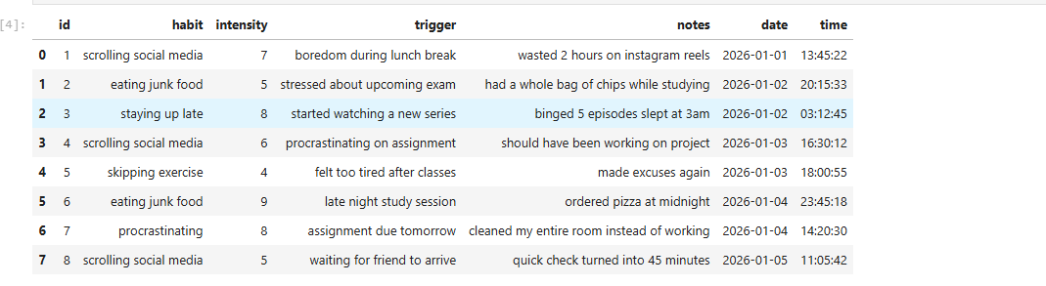

- Viewing all tasks
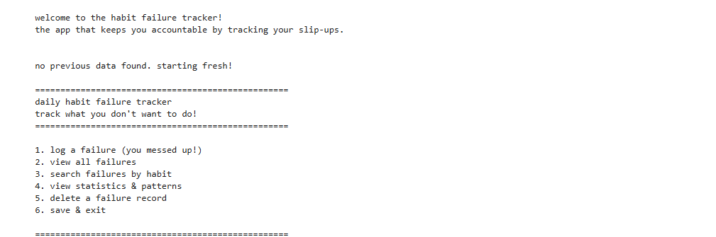

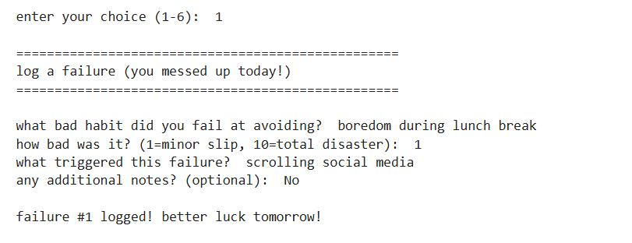
- Updating task status
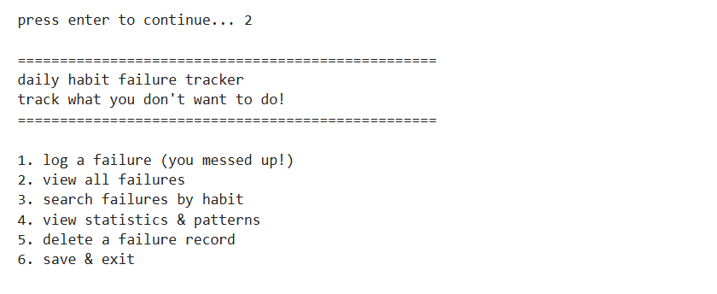
- Searching task by Task ID
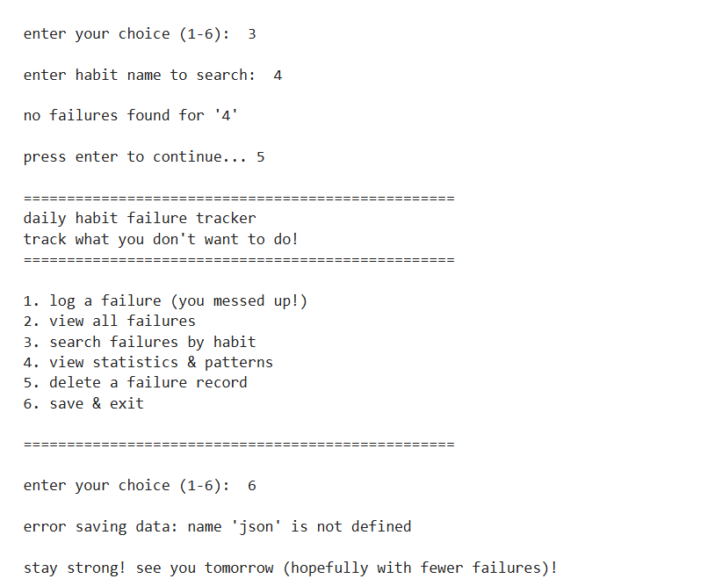

Assignment Fit and Extras
- Meets Assignment Requirements – Suitable for Python mini-project.
- Real-World Application – Useful for students and professionals.
- Structured Programming – Uses functions, loops, and conditions.
- Error Handling – Includes exception handling.
- Data Persistence – Implements file handling.
- Easy to Extend – Can be enhanced with reports and analytics.

Name: Mohammed Washif Shareef
USN: 1BG24BA073
Course: Python Programming
Project: Habit Failure Log
Domain: Task Management / Healthcare

